# CLOUD APPLICATIONS DEVELOPMENT

## TOPIC: IMAGE RECOGNITION WITH IBM CLOUD VIRTUAL RECOGNITION

### PHASE 3

TEAM LEADER

S.RITHIK

TEAM MEMBERS

C.SUYAMBURAJ

G.KARTHICKRAJA

L.MOTHIR

N.MADHANKUMAR

# Create an IBM Cloud account

STEP 1 : LOGIN SKILLUP ID



STEP 2 : GO TO myclass.skillup.online

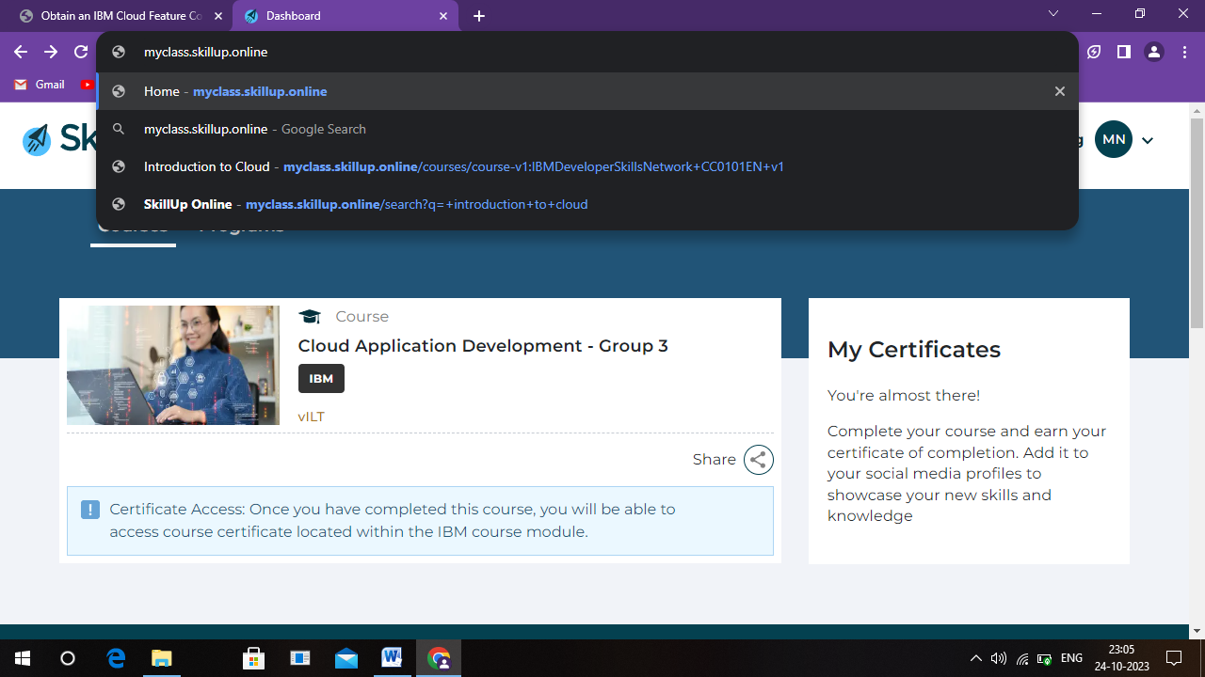

STEP 3 : In search bar search INTRODUTION TO CLOUD

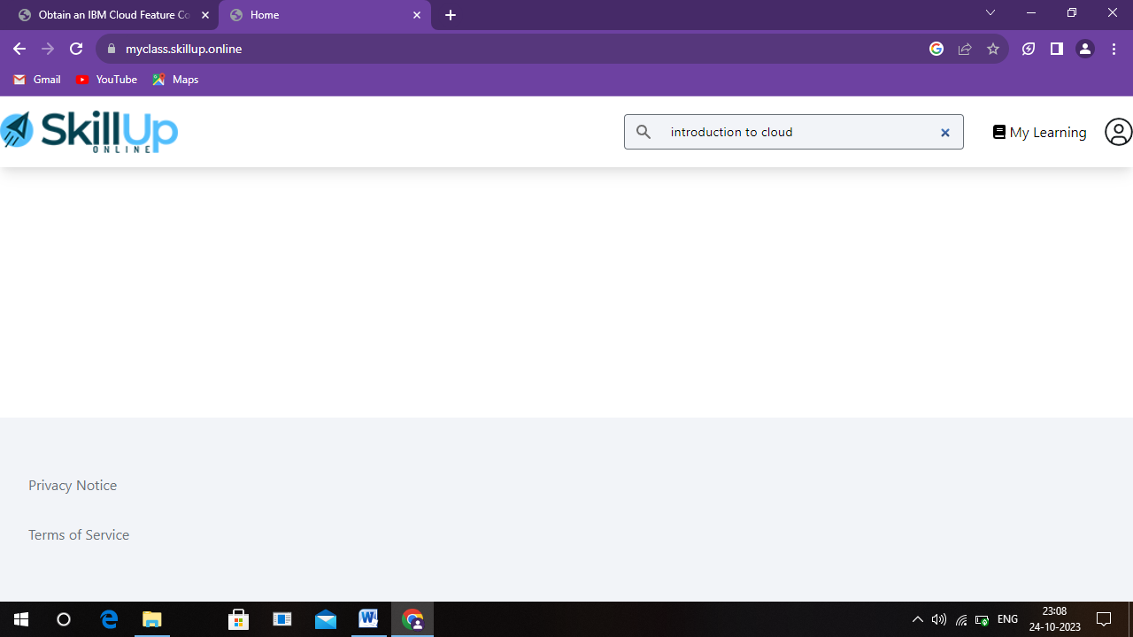

STEP 4 : ENTROLL THE COURSE

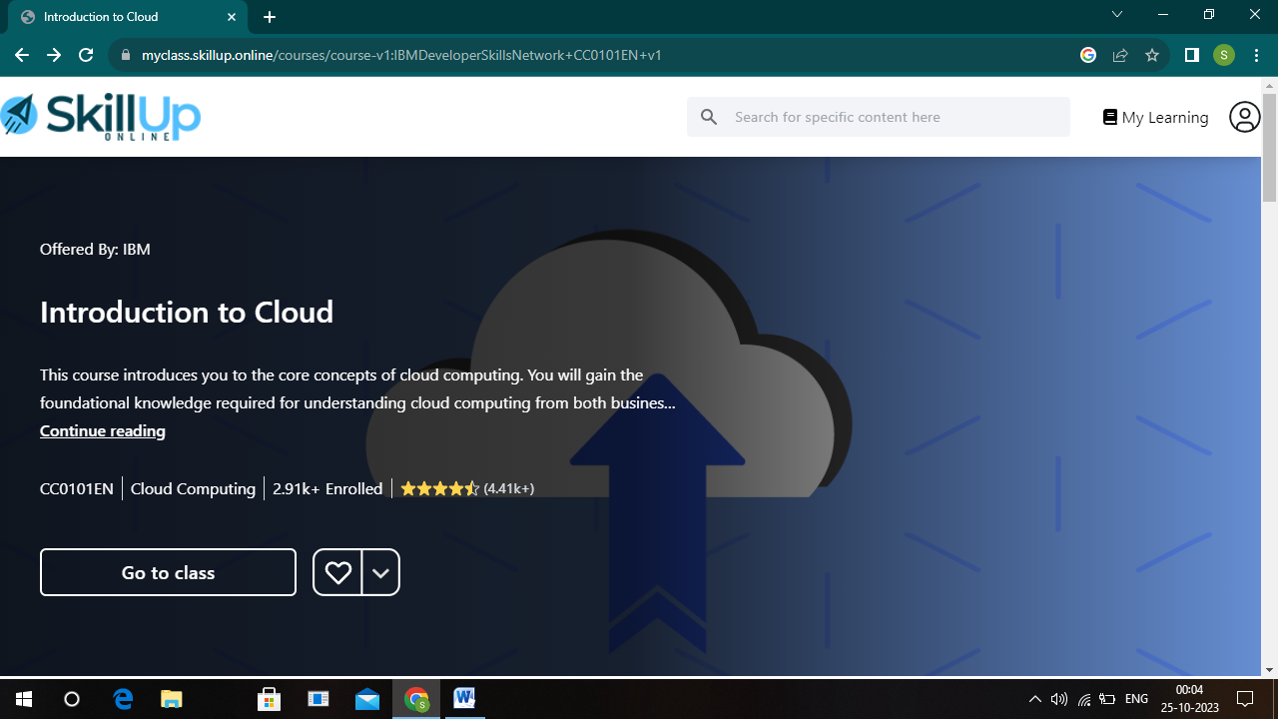

STEP 5 : click MODULE 1 and click obtain the IBM CLOUD FEATURE CODE

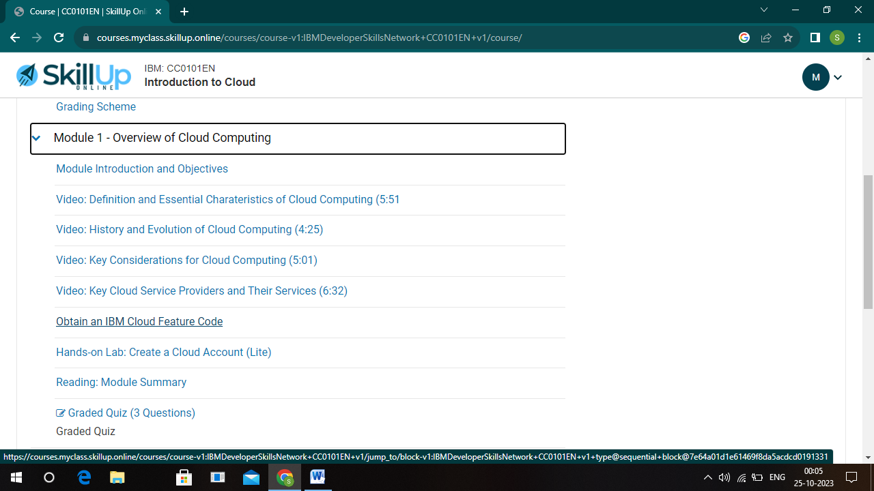

STEP 6 : SCROLL AND CLICK OPEN TOOLS

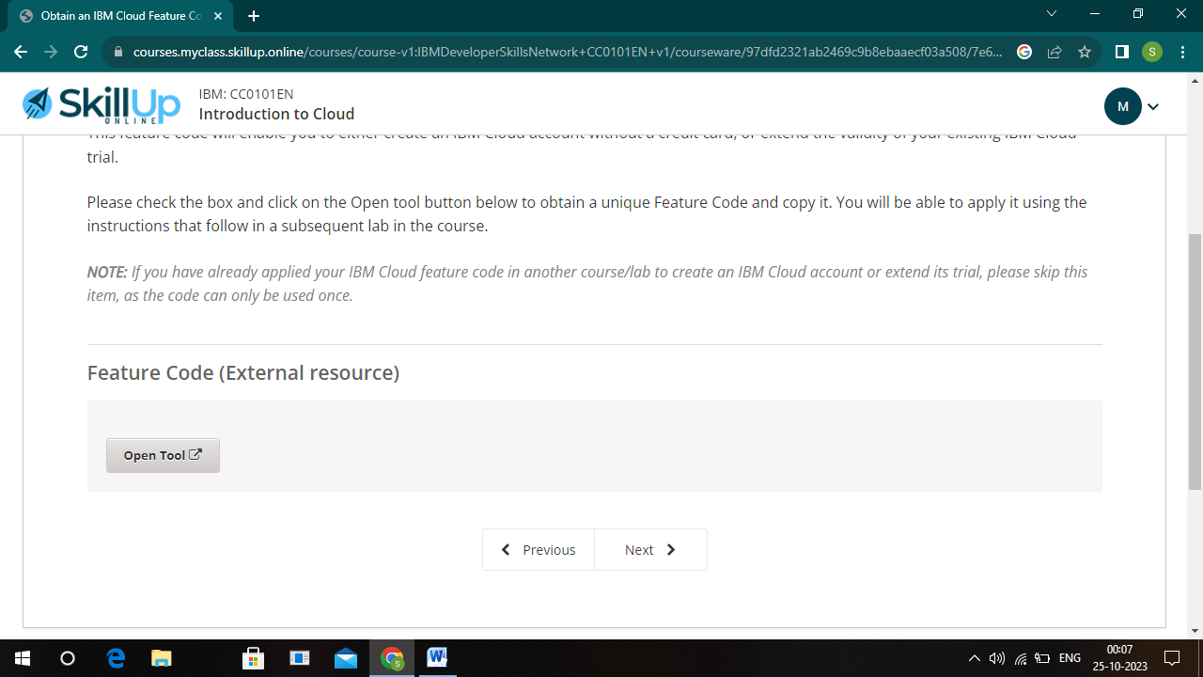

STEP 7 : then open alert message and open CLICK OK

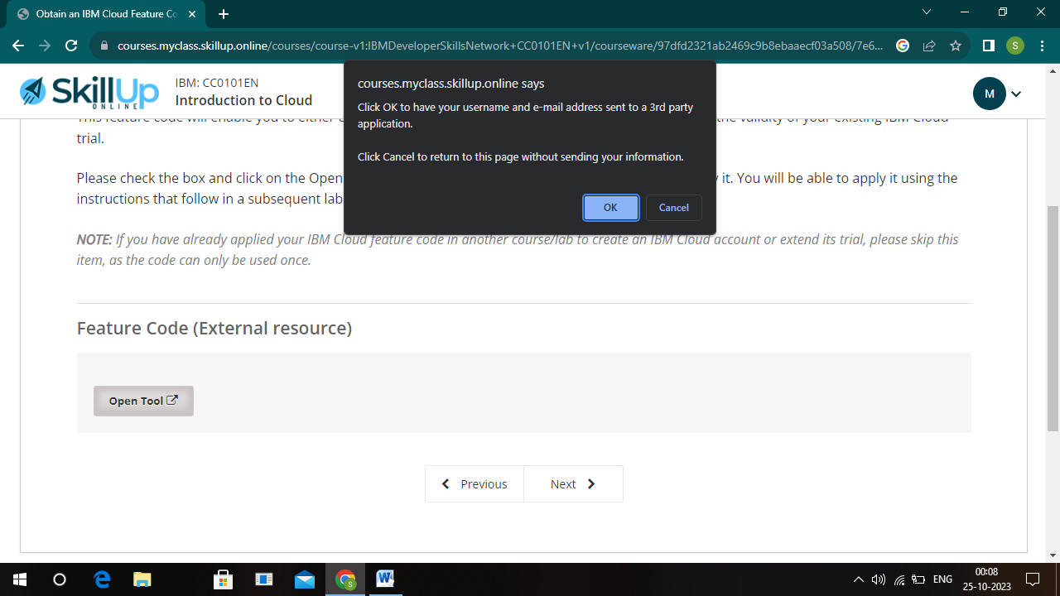

STEP 8 : IT OPEN IBM CLOUD FEATURE CLOUD AND CLICK ACTIVATE YOUR TRAIL

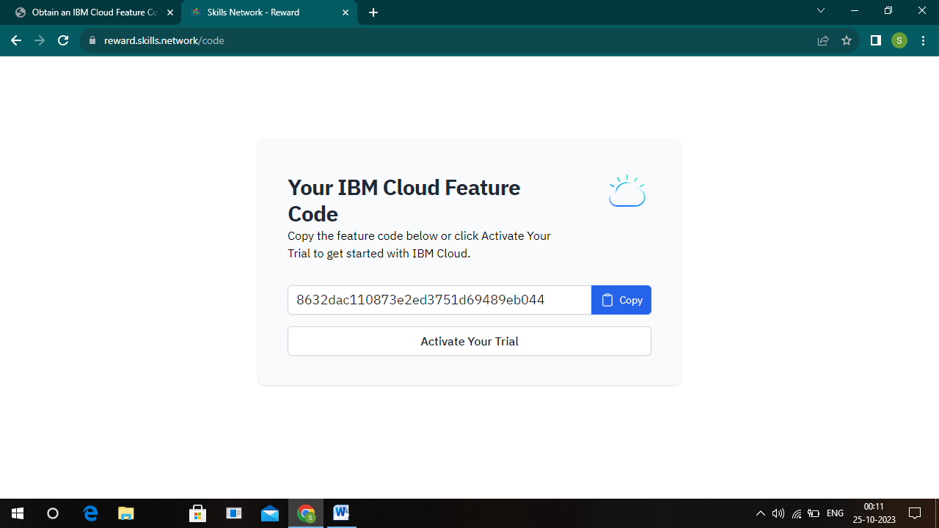

STEP 9 : IT OPEN IBM CLOUD SIGNUP DO SIGNUP DETAIL

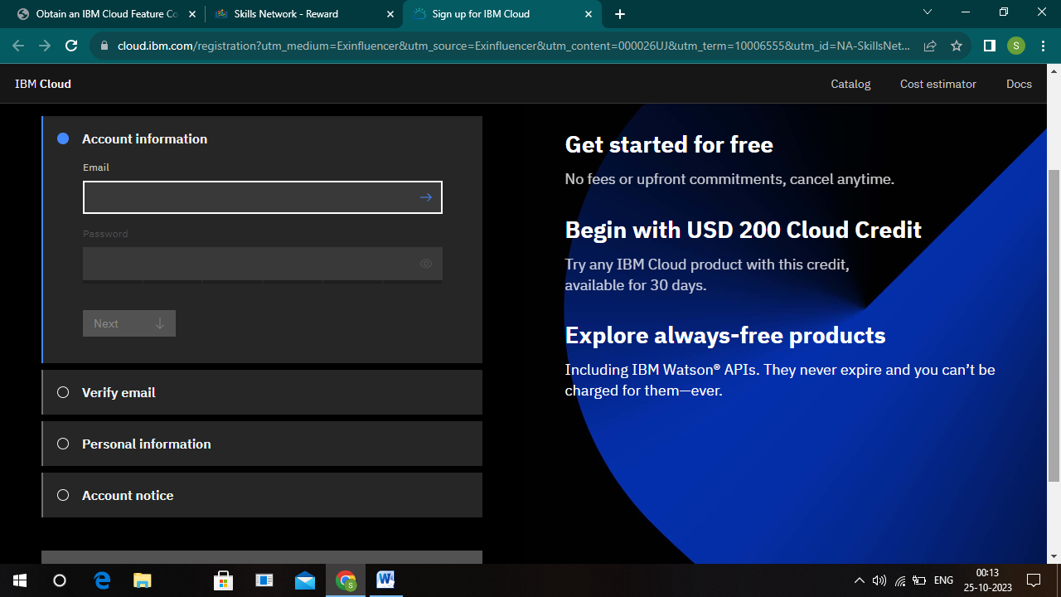

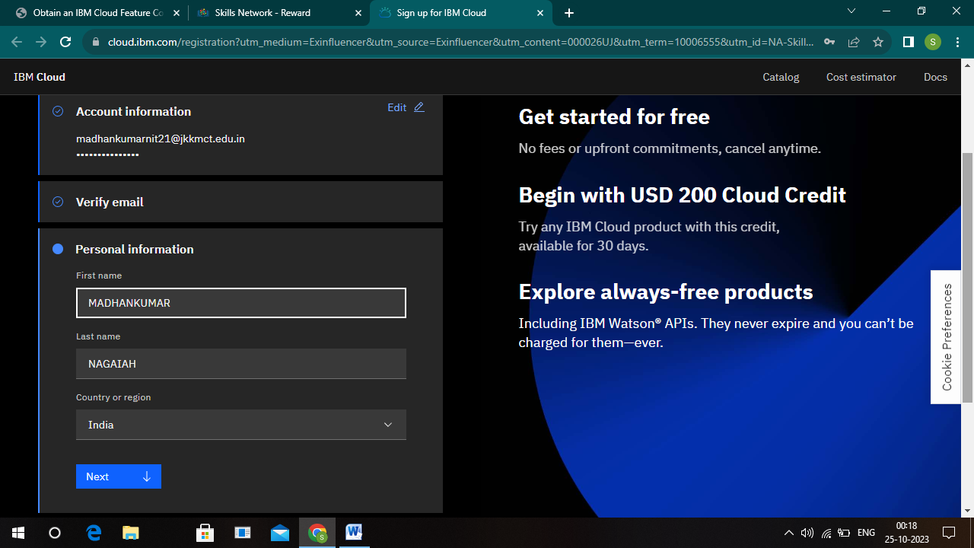

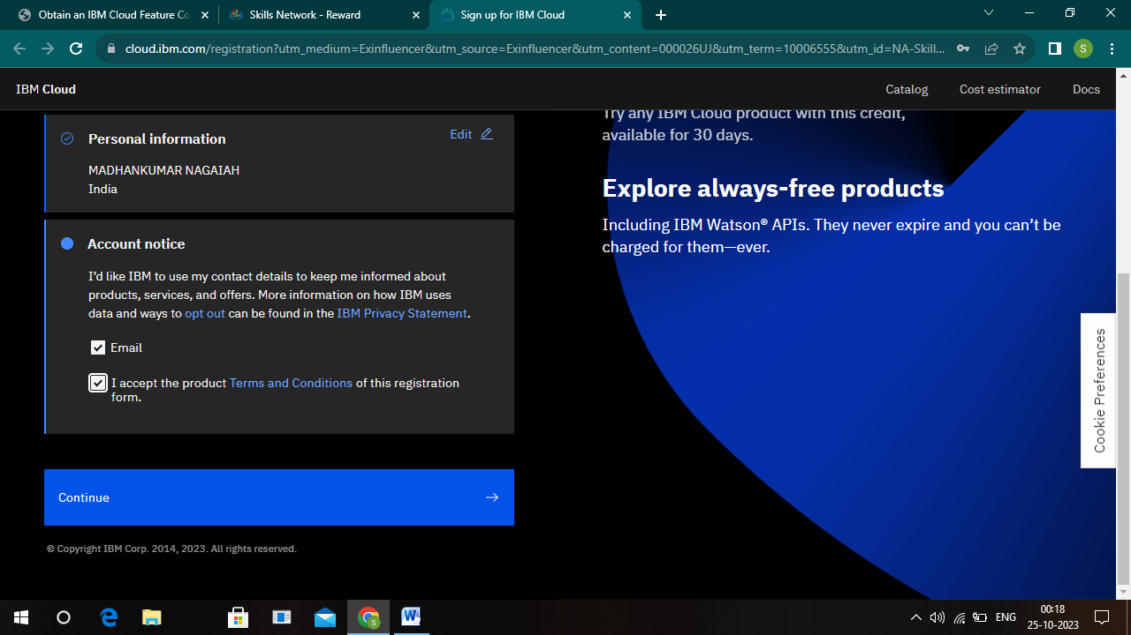

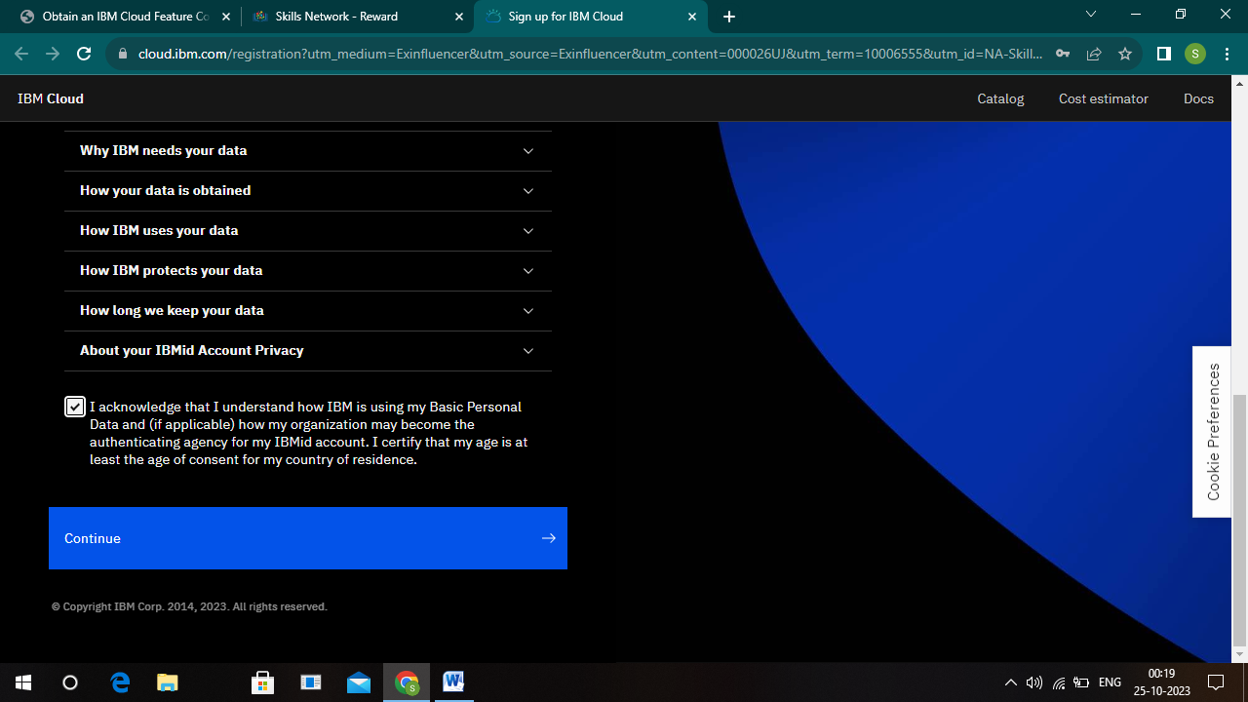

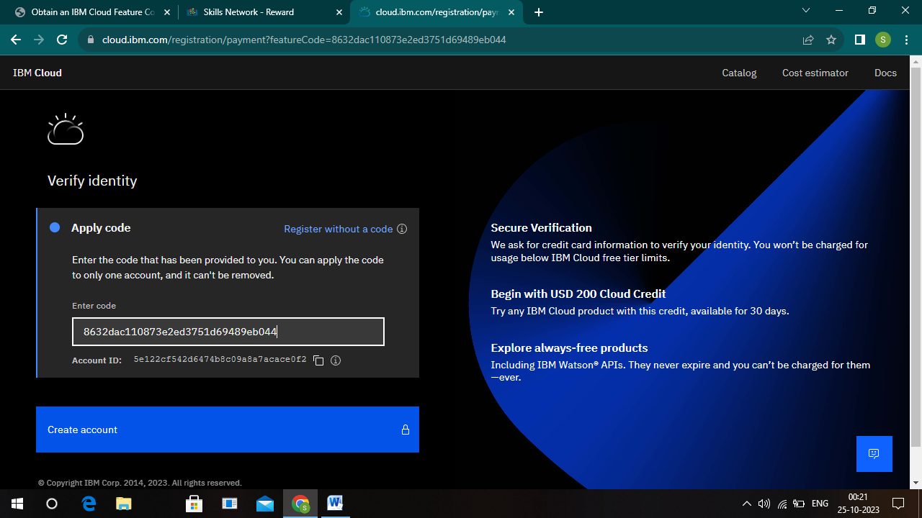

STEP 10 : SUCCESSFULLY IBM CLOUD ACCOUNT IS CREATED

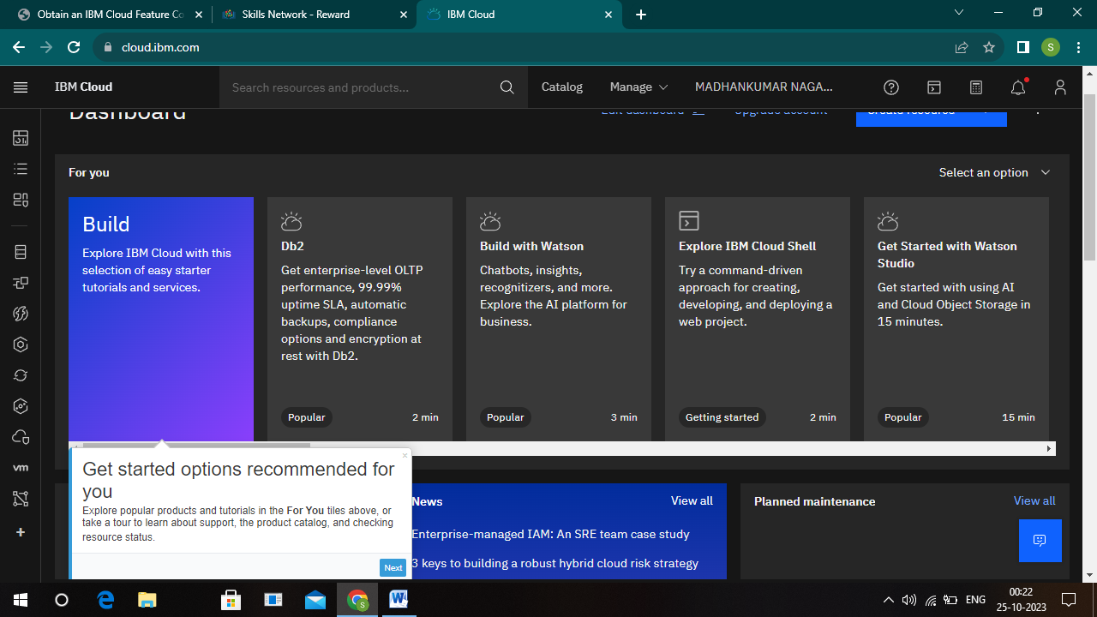

# Set up the Visual Recognition service, and obtain API keys.

# STEP 1 : "Catalog," search for "Visual Recognition"

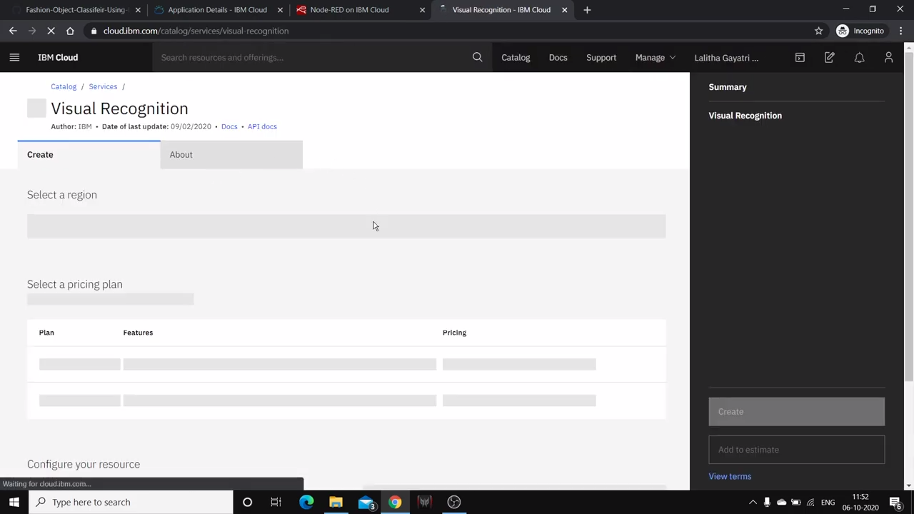

STEP 2 :Click the "Create" button to set up the service.

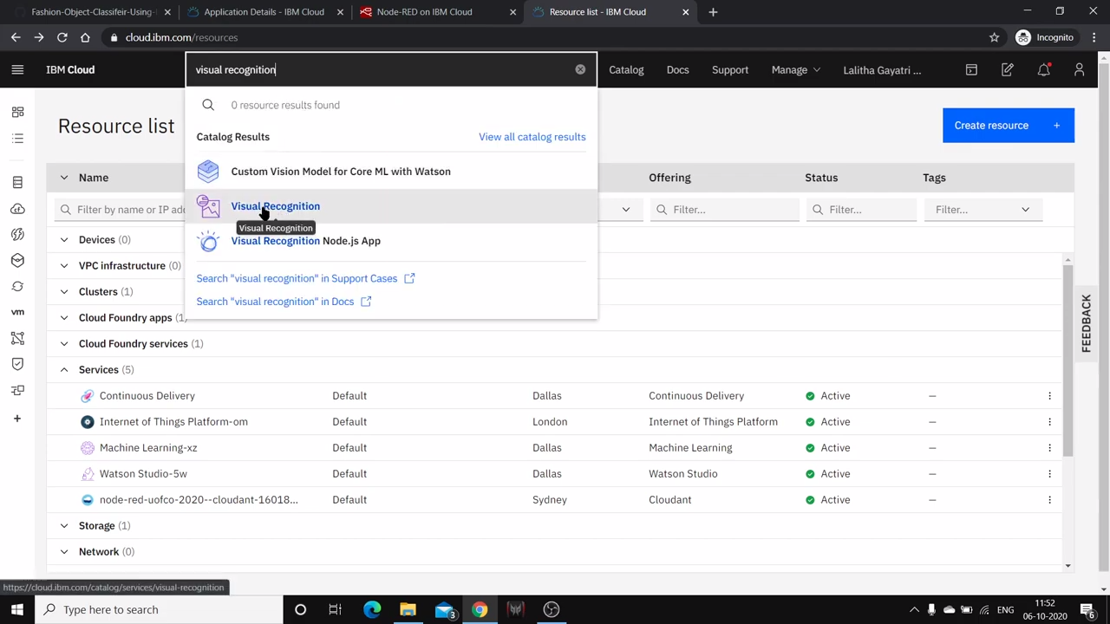

STEP 3 : You will be prompted to give your service a name, choose a region, and select a plan AND Click "Create" to provision the service.

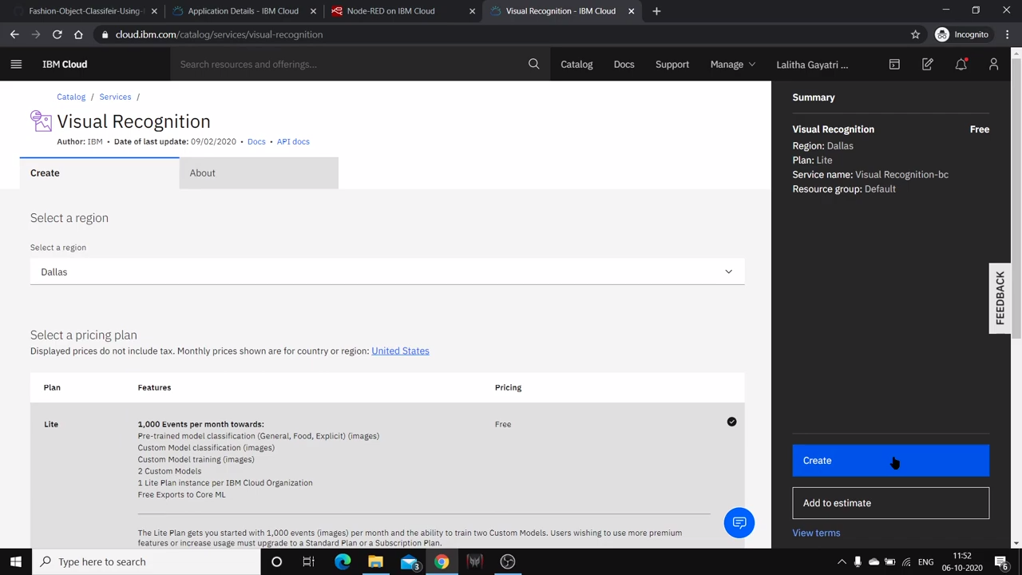

STEP 4 : Launch Watson studio

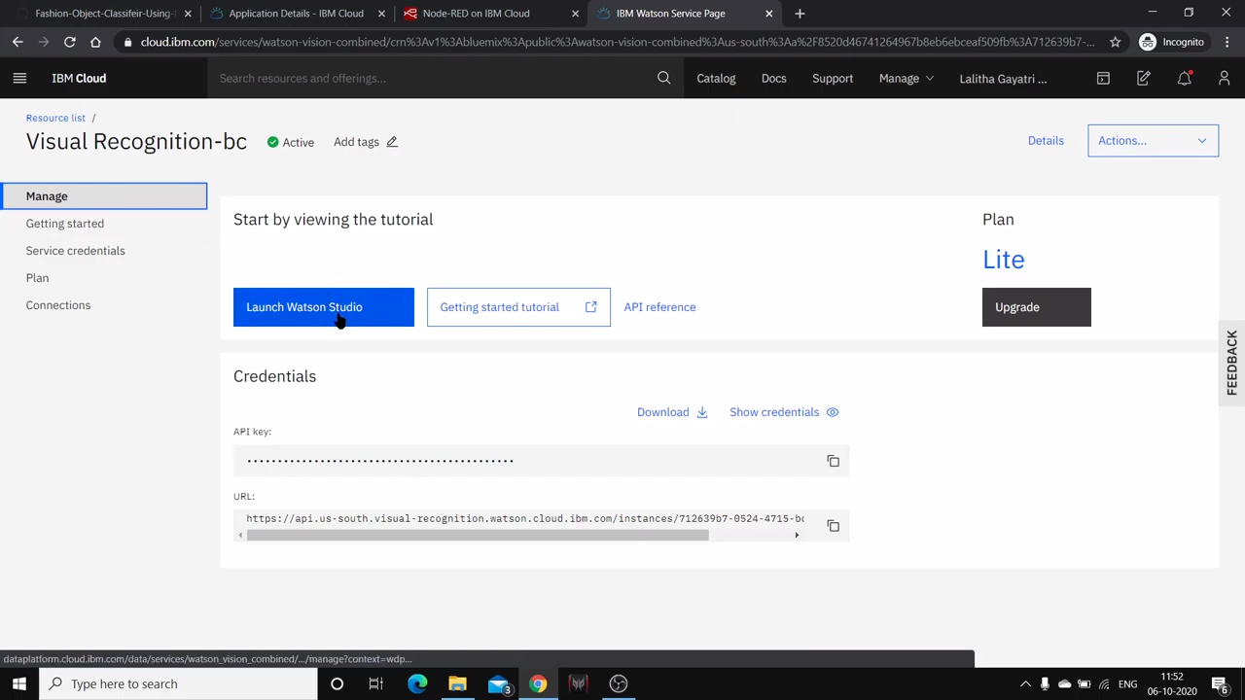

STEP 5 : When you click "View credentials," you'll find the API key and other relevant information needed to access the Visual Recognition service

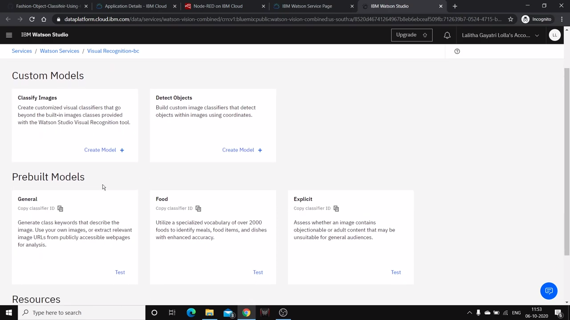

# Design a simple web interface where users can upload images and view the AI-generated captions.

<!DOCTYPE html>

<html lang=”en”>

<head>

<meta charset=”UTF-8”>

<meta name=”viewport” content=”width=device-width, initial-scale=1.0”>

<title>Image Recognition System</title>

<link rel=”stylesheet” href=”styles.css”>

</head>

<body>

<header>

<h1>Image Recognition System</h1>

</header>

<section>

<form enctype=”multipart/form-data” action=”upload” method=”post”>

<input type=”file” name=”image” accept=”image/*”>

<button type=”submit”>Upload</button>

</form>

</section>

<section id=”result”>

<h2>AI-Generated Caption:</h2>

<p id=”caption”>Waiting for image recognition…</p>

</section>

<footer>

<p>&copy; 2023 Image Recognition System. All rights reserved.

</p>

</footer>

</body>

</html>

Output

